**What is app development?**

App development is the process in which developers [create an application to be used on smartphones](https://orases.com/mobile-app-development/), tablets and other mobile devices. While app development sometimes involves creating a [web-based app or a desktop version of the app,](https://orases.com/what-is-web-application-development/) the majority of app development projects are deployed to mobile and tablet devices.

**The App Development Lifecycle**

The app development lifecycle features several steps involved in a typical app development project. These steps include:

1. Planning

This first stage involves completing a business analysis and creating a mobile strategy. A business analysis, marketer and project manager are usually involved.

2. Technical

In this next stage, a technical writer is responsible for describing all technical details and requirements.

3. Prototyping

In the prototyping phase, the sketch, wireframes and app skins are created. This is usually completed by a UX/UI designer.

4. Developing

This phase includes front-end and back-end coding segments and is performed by developers.

5. Quality

During the quality assurance phase, tech requirements are tested and the device capability is reviewed to ensure that the app is working as it should.

6. Publishing

Finally, the app is published to the app store. Maintenance is provided on an ongoing basis as updates, new releases and new bugs arise.

During the coding process, developers encounter two main types of paths:

Front End and Back End.

**Front End** developers focus on how an app looks, while **Back End** developers focus on how an app works.

For example, if you were building an app, the front-end developer would be in charge of creating the theme, style, presentation, and images.

The back-end developer would work on the database, as well as the site’s security, users and overall site performance. Programming languages can also differ. For example, front end developers often use HTML, JavaScript, or CSS, while back end users may use Ruby, PHP, Python, Java

The best way to build web apps without code.

**No-Code**

No-code doesn't mean anti-code. There will always be a place for developers and their expertise. But not knowing how to code shouldn't stop people from being able to launch their ideas, build businesses, and follow their entrepreneurial aspirations. It's exciting to see so many no code development platforms out there opening up the gateways for non-programmers to create.

**What is No-Code?**

No-code frameworks are software design systems that allow even non-technical people to execute software without composing a line of code.

These tools usually have a user-friendly interface and drag-and-drop capabilities, allowing you to envision the implementation process and describe the overall business logic with ease.

A no-code framework is a programming platform that uses a visual development interface to enable non-technical users to build applications by dragging and dropping software components to create a full app. Users don’t need any previous coding experience to build applications using no-code

**Why No-Code?**

* Hands-on approach to building a mobile app without writing a single line of code
* Methodological approach towards building No-Code apps in 50% less time.
* Reduce the cost of development by up to 80%
* You will be able to attract better clients, who pay for the value and not for the hours.
* Higher paying jobs.
* Be an independent professional.
* You will be able to advice your clients on No-Code.
* Develop Logical Thinking.
* No-code automation systems minimize mistakes and speed up business operations while still reducing routine and redundant tasks. It is why the majority of teams opt for no-code.

**Who is this program for?**

**Designers**

Go beyond the UI prototypes and actually build a working model of your design. Be a complete package.

**Entrepreneurs**

Test your ideas on a smaller scale by launching prototypes fast. Expand and invest on what the customers pay for.

**Freelancers**

Increase your service offerings. Execute projects much faster. Attract high-ticket clients.

**Digital Marketers**

Utilise advanced analytics to track user activity and manage funnels. Collect critical data without the need to write complex scripts from scratch.

**Small Businesses**

Selling online has never been easier and more accessible. Take your business to the internet and let the whole world buy from you.

**Developers**

Why spend months to build software, when you can use a No-Code tool to quickly build a product and write code only to enhance its capabilities even further.

Few are the examples of No-Code given below:-

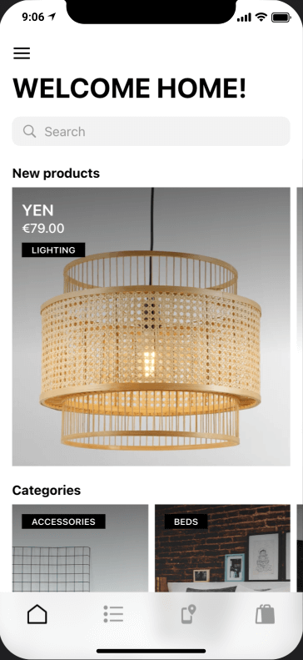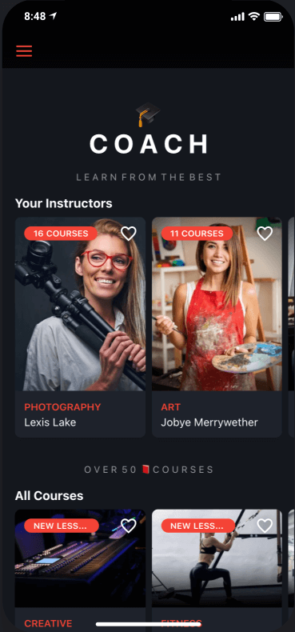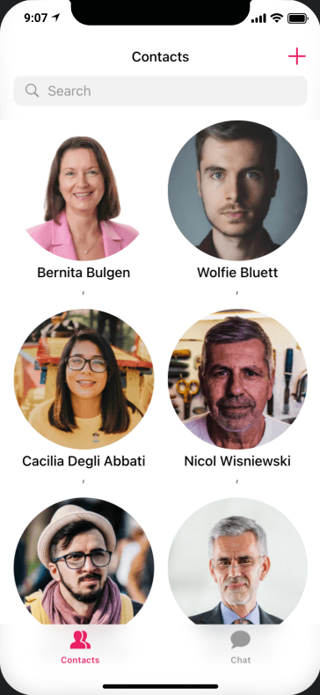

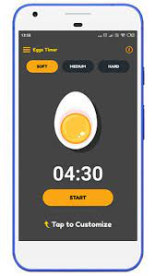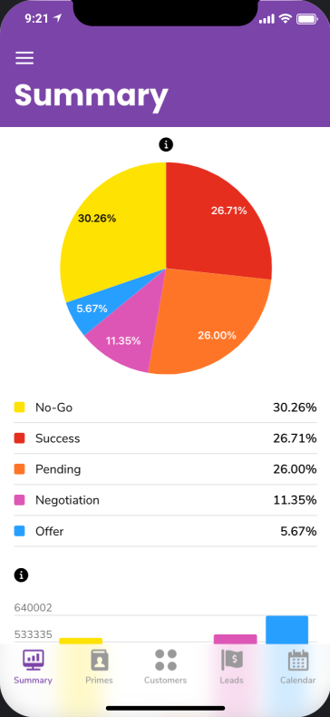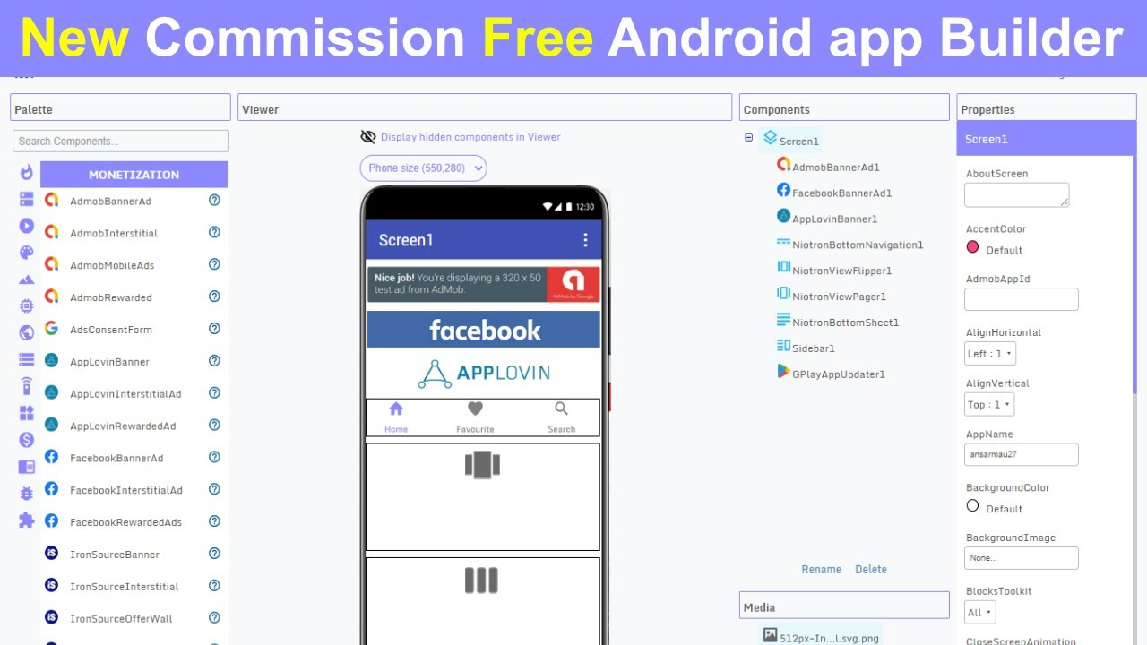

FAQ’s:-

1) Will this be live or recorded session?

This is going to conduct Live session

2) Would there be any certificate on completion?

Yes, there will be certificate on completion of course

3) What will be the time?

You can get all the details related to the date and timing by your instructor.